Ex No 2 | Design a web application front-end using HTML, CSS, JS  (Hostel Management System)
8/July/2025

AIM:
To design and develop the front-end of a web application using HTML, CSS, and JavaScript, implementing responsive design principles, layout structuring, and basic interactivity to create an engaging user interface.
CODE:
Indedx.php
<?php
session_start();
include('includes/config.php');
if(isset($_POST['login']))
{
$username=$_POST['username'];
$password=$_POST['password'];
$stmt=$mysqli->prepare("SELECT username,email,password,id FROM admin WHERE (userName=?|| email=?) and password=? ");
$stmt->bind_param('sss',$username,$username,$password);
$stmt->execute();
$stmt -> bind_result($username,$username,$password,$id);
$rs=$stmt->fetch();
$_SESSION['id']=$id;
$uip=$_SERVER['REMOTE_ADDR'];
$ldate=date('d/m/Y h:i:s', time());
if($rs)
{
// $insert="INSERT into admin(adminid,ip)VALUES(?,?)";
// $stmtins = $mysqli->prepare($insert);
// $stmtins->bind_param('sH',$id,$uip);
//$res=$stmtins->execute();
header("location:admin-profile.php");
}

else
{
echo "<script>alert('Invalid Username/Email or password');</script>";
}
}
?>
OUTPUT:
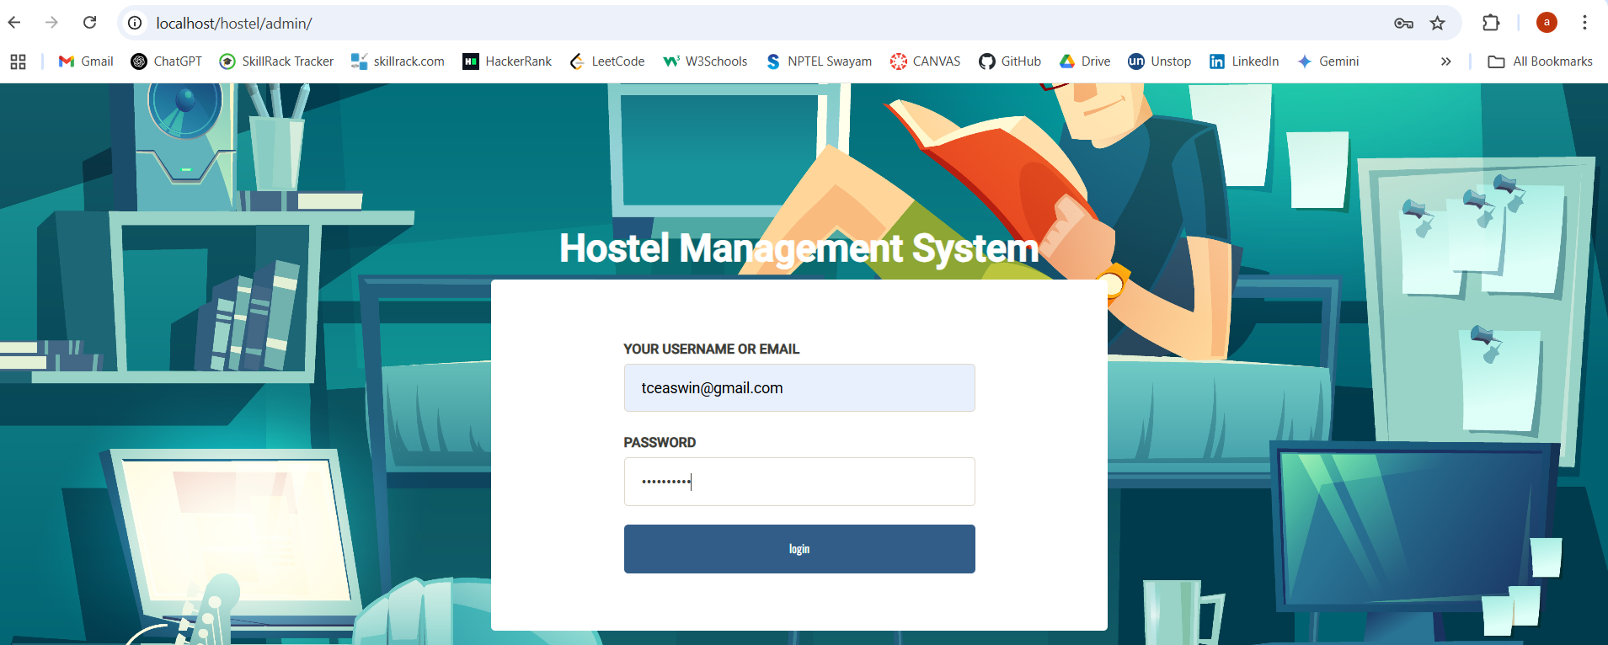

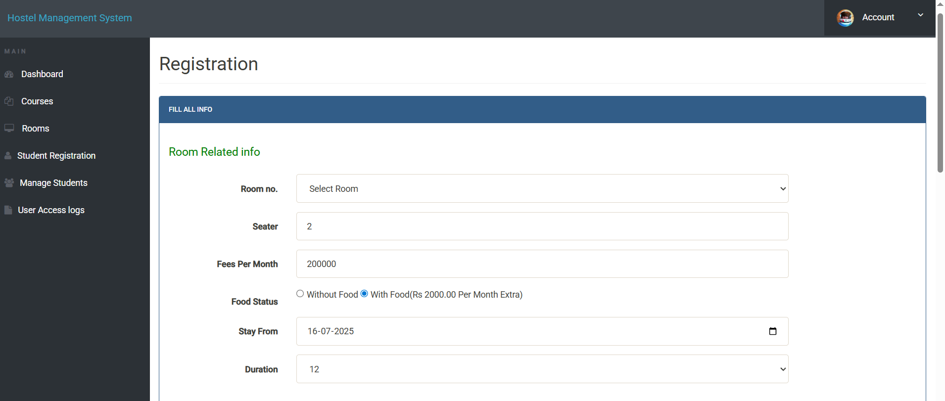

<!doctype html>
<html lang="en" class="no-js">
<head>
<meta charset="UTF-8">
<meta http-equiv="X-UA-Compatible" content="IE=edge">
<meta name="viewport" content="width=device-width, initial-scale=1, minimum-scale=1, maximum-scale=1">
<meta name="description" content="">
<meta name="author" content="">

<title>Admin login</title>

<link rel="stylesheet" href="css/font-awesome.min.css">
<link rel="stylesheet" href="css/bootstrap.min.css">
<link rel="stylesheet" href="css/dataTables.bootstrap.min.css">
<link rel="stylesheet" href="css/bootstrap-social.css">
<link rel="stylesheet" href="css/bootstrap-select.css">
<link rel="stylesheet" href="css/fileinput.min.css">
<link rel="stylesheet" href="css/awesome-bootstrap-checkbox.css">
<link rel="stylesheet" href="css/style.css">
</head
<body>

<div class="login-page bk-img" style="background-image: url(img/login-bg.jpg);">
<div class="form-content">
<div class="container">
<div class="row">
<div class="col-md-6 col-md-offset-3" style="margin-top:4%">
<h1 class="text-center text-bold text-light mt-4x">Hostel Management System</h1>
<div class="well row pt-2x pb-3x bk-light">
<div class="col-md-8 col-md-offset-2">

<form action="" class="mt" method="post">
<label for="" class="text-uppercase text-sm">Your Username or Email</label>
<input type="text" placeholder="Username" name="username" class="form-control mb">
<label for="" class="text-uppercase text-sm">Password</label>
<input type="password" placeholder="Password" name="password" class="form-control mb">

<input type="submit" name="login" class="btn btn-primary btn-block" value="login" >
</form>
</div>
</div>
</div>
</div>

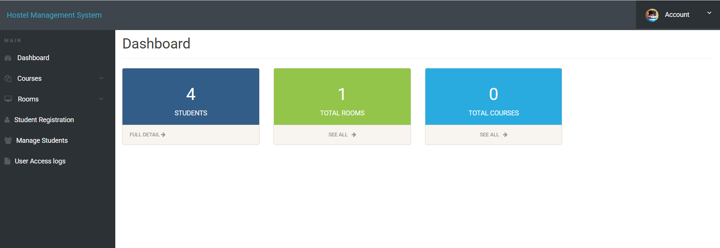

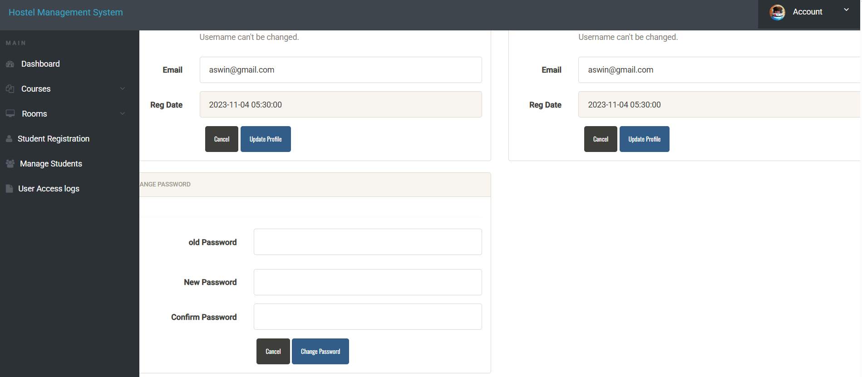

</div>
</div>
</div>
<script src="js/jquery.min.js"></script>
<script src="js/bootstrap-select.min.js"></script>
<script src="js/bootstrap.min.js"></script>
<script src="js/jquery.dataTables.min.js"></script>
<script src="js/dataTables.bootstrap.min.js"></script>
<script src="js/Chart.min.js"></script>
<script src="js/fileinput.js"></script>
<script src="js/chartData.js"></script>
<script src="js/main.js"></script>
</body>
</html>

Hoste.css
body {
margin-left: 0px;
margin-top: 0px;
margin-right: 0px;
margin-bottom: 0px;font:11px Verdana,Arial;
}

ul.menu {list-style:none; margin:0; padding:0}
ul.menu * {margin:0; padding:0}
ul.menu a {display:block; color:#000; text-decoration:none}
ul.menu li {position:relative; float:left; margin-right:2px}
ul.menu ul {position:absolute; top:26px; left:0; background:#d1d1d1; display:none; opacity:0; list-style:none}
ul.menu ul li {position:relative; border:1px solid #aaa; border-top:none; width:148px; margin:0}
ul.menu ul li a {display:block; padding:3px 7px 5px; background-color:#d1d1d1}
ul.menu ul li a:hover {background-color:#c5c5c5}
ul.menu ul ul {left:148px; top:-1px}
ul.menu .menulink {border:1px solid #aaa; padding:5px 7px 7px; font-weight:bold; /*background:url(images/header.gif);*/ width:134px}
/*ul.menu .menulink:hover, ul.menu .menuhover {background:url(images/header_over.gif)}
*/ul.menu .sub {background:#d1d1d1 url(images/arrow.gif) 136px 8px no-repeat}
ul.menu .topline {border-top:1px solid #aaa}
.left{ font-family:Verdana, Arial, Helvetica, sans-serif; font-size:11px; color:#FFFFFF; font-weight:bold }
.JT {
BORDER-RIGHT:#666666 1px solid; Z-INDEX: 100; background-color:#DBDBDB; BORDER-LEFT:#666666 1px solid;
}
.JT1 {
BORDER-LEFT:#666666 1px solid; Z-INDEX: 100; BORDER-RIGHT:#666666 1px solid;
}

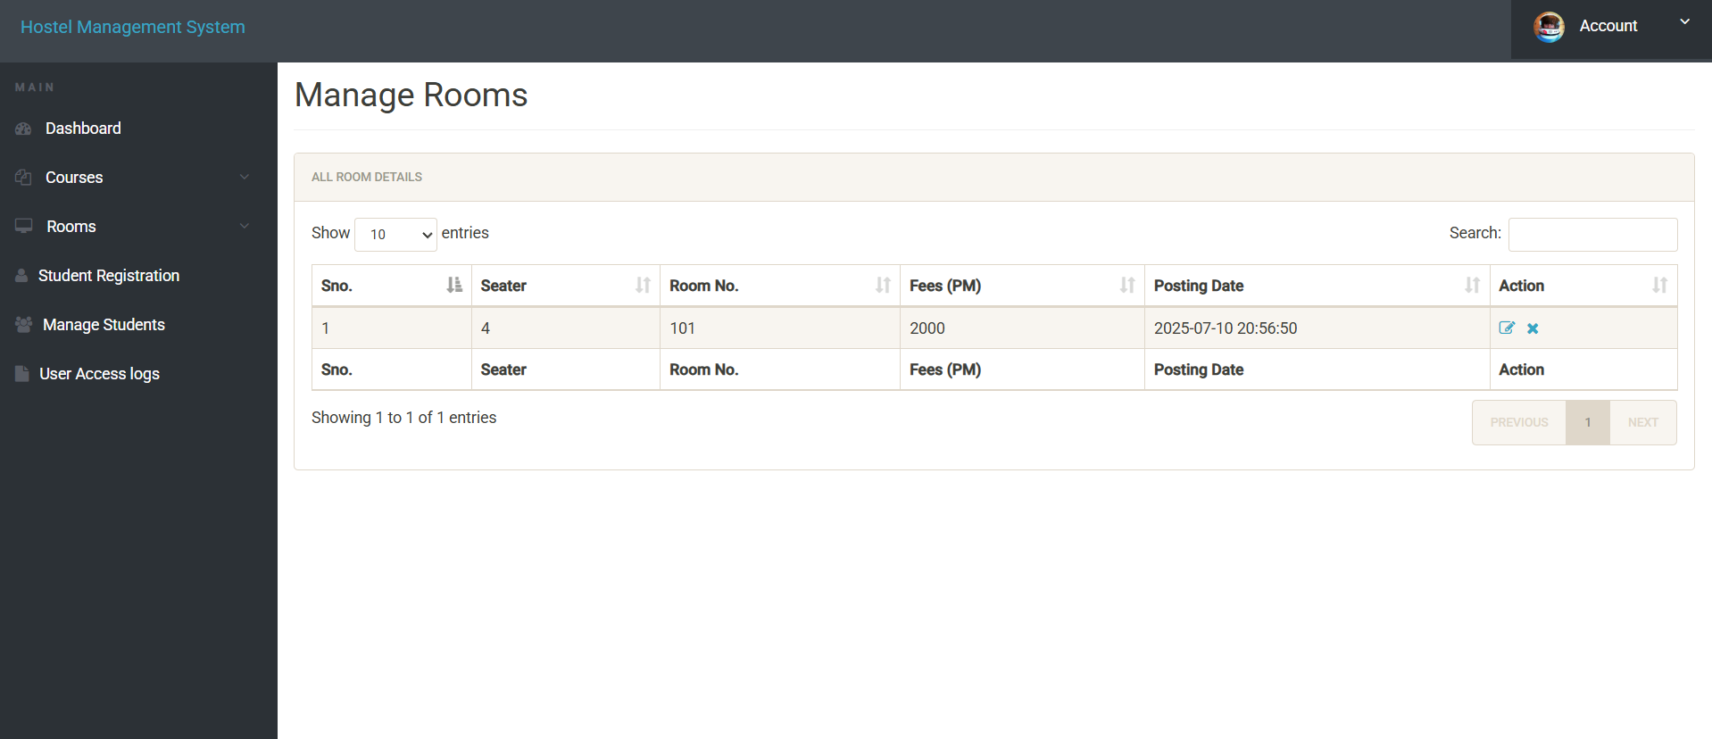

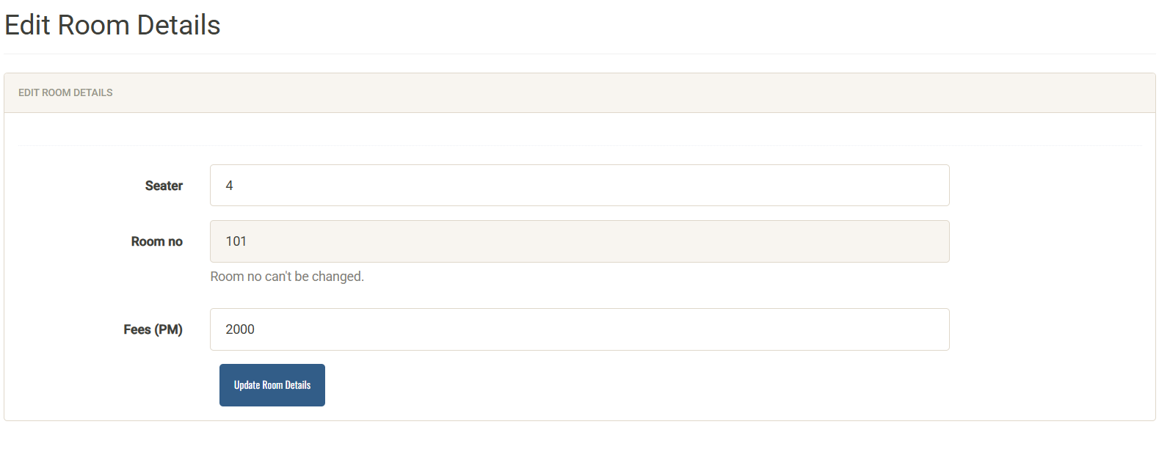

Registration.php
<?php
session_start();
include('includes/config.php');
if(isset($_POST['submit']))
{
$regno=$_POST['regno'];
$fname=$_POST['fname'];
$mname=$_POST['mname'];
$lname=$_POST['lname'];
$gender=$_POST['gender'];
$contactno=$_POST['contact'];
$emailid=$_POST['email'];
$password=$_POST['password'];
$query="insert into userRegistration(regNo,firstName,middleName,lastName,gender,contactNo,email,password) values(?,?,?,?,?,?,?,?)";
$stmt = $mysqli->prepare($query);
$rc=$stmt->bind_param('sssssiss',$regno,$fname,$mname,$lname,$gender,$contactno,$emailid,$password);
$stmt->execute();
echo"<script>alert('Student Succssfully register');</script>";
}
?>

Result:
Thus, the front-end of the web application was successfully designed and implemented using HTML, CSS, and JavaScript, and the output was verified to be responsive and functional across different devices and browsers.

